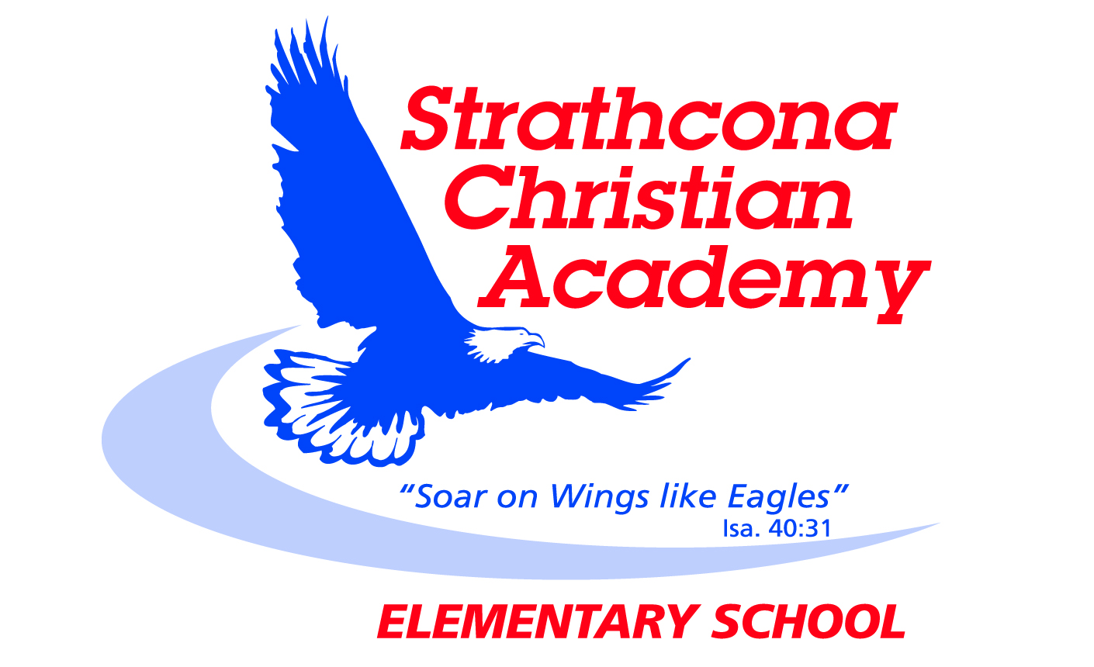
Kindergarten Bible Memory

Month | Verse
September | Psalm 23:1  The Lord is my shepherd, I lack nothing.
October | Psalm 23:2  He makes me lie down in green pastures,  he leads me beside quiet waters
November | Psalm 23:3  He refreshes my soul. He guides me along the right paths for his name’s sake.
December | Psalm 23:4  Even though I walk through the darkest valley, I will fear no evil, for you are with me; your rod and your staff, they comfort me.
January | Psalm 23:5  You prepare a table before me in the presence of my enemies. You anoint my head with oil; my cup overflows.
February | Psalm 23:6  Surely your goodness and love will follow me  all the days of my life, and I will dwell in the house of the Lord forever.
March | Psalm 23:1, 2  ¹ The Lord is my shepherd, I lack nothing. ² He makes me lie down in green pastures, he leads me beside quiet waters
April | Psalm 23:3, 4  ³ he refreshes my soul. He guides me along the right paths for his name’s sake. ⁴ Even though I walk through the darkest valley, I will fear no evil, for you are with me; your rod and your staff, they comfort me.
May | Psalm 23: 5, 6  ⁵ You prepare a table before me in the presence of my enemies. You anoint my head with oil; my cup overflows. ⁶ Surely your goodness and love will follow me all the days of my life, and I will dwell in the house of the Lord forever.
June | Review all  ¹ The Lord is my shepherd, I lack nothing. ² He makes me lie down in green pastures, he leads me beside quiet waters, ³ he refreshes my soul. He guides me along the right paths for his name’s sake. ⁴ Even though I walk through the darkest valley, I will fear no evil, for you are with me; your rod and your staff, they comfort me.  ⁵ You prepare a table before me in the presence of my enemies. You anoint my head with oil; my cup overflows. ⁶ Surely your goodness and love will follow me all the days of my life, and I will dwell in the house of the Lord forever.

Updated September 2014

