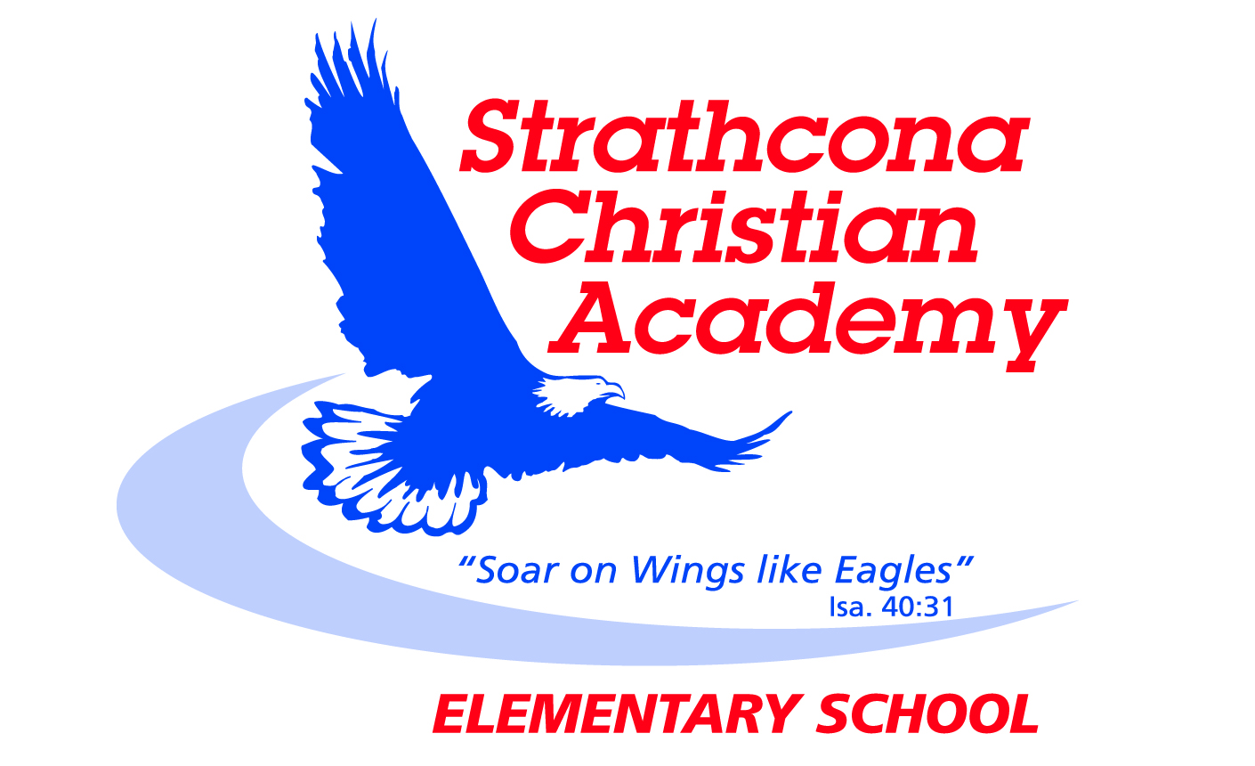
Grade 2 Bible Memory

Month | Week | Verse
SEPTEMBER | Week 1 | John 3:16*  For God so loved the world that he gave his one and only Son, that whoever believes in him shall not perish but have eternal life.
 | Week 2 | Matthew 22:37*  Jesus replied: “‘Love the Lord your God with all your heart and with all your soul and with all your mind.’
 | Week 3 | Matthew 22:38*  This is the first and greatest commandment.
OCTOBER | Week 1 | Matthew 22:39*  And the second is like it: ‘Love your neighbor as yourself.’
 | Week 2 | Matthew 22:40*  All the Law and the Prophets hang on these two commandments.
 | Week 3 | Matthew 22:37-40*  ³⁷ Jesus replied: “‘Love the Lord your God with all your heart and with all your soul and with all your mind.’ ³⁸ This is the first and greatest commandment. ³⁹ And the second is like it: ‘Love your neighbor as yourself.’ ⁴⁰ All the Law and the Prophets hang on these two commandments.”
NOVEMBER | Week 1 | Matthew 28:19*  Therefore go and make disciples of all nations, baptizing them in the name of the Father and of the Son and of the Holy Spirit.
 | Week 2 | Matthew 7:12*  So in everything, do to others what you would have them do to you, for this sums up the Law and the Prophets.
 | Week 3 | Galatians 5:22-23a*  But the fruit of the Spirit is love, joy, peace, patience, kindness, goodness, faithfulness, gentleness and self-control.
DECEMBER | Week 1 | Galatians 5:23b*  Against such things there is no law.
 | Week 2 | Galatians 5:22-23*  ²² But the fruit of the Spirit is love, joy, peace, patience, kindness, goodness, faithfulness, ²³ gentleness and self-control. Against such things there is no law.
 | Week 3 | Psalms 23:1  The Lord is my shepherd, I lack nothing.
JANUARY | Week 1 | Psalms 23:2  He makes me lie down in green pastures, he leads me beside quiet waters,
 | Week 2 | Psalms 23:3  he refreshes my soul. He guides me along the right paths  for his name’s sake.
 | Week 3 | Psalms 23:4  Even though I walk through the darkest valley, I will fear no evil, for you are with me; your rod and your staff,  they comfort me.
FEBRUARY | Week 1 | Psalms 23:5  You prepare a table before me in the presence of my enemies. You anoint my head with oil; my cup overflows.
 | Week 2 | Psalms 23:6  Surely your goodness and love will follow me all the days of my life, and I will dwell in the house of the Lord forever.
 | Week 3 | Psalms 23:1-6  ¹ The Lord is my shepherd, I lack nothing. ² He makes me lie down in green pastures, he leads me beside quiet waters, ³ he refreshes my soul. He guides me along the right paths for his name’s sake. ⁴ Even though I walk through the darkest valley, I will fear no evil, for you are with me; your rod and your staff,  they comfort me. ⁵ You prepare a table before me  in the presence of my enemies. You anoint my head with oil; my cup overflows. ⁶ Surely your goodness and love will follow me all the days of my life, and I will dwell in the house of the Lord forever.
MARCH | Week 1 | John 3:16*  For God so loved the world that he gave his one and only Son, that whoever believes in him shall not perish but have eternal life.
 | Week 2 | Matthew 22:37*  Jesus replied: “‘Love the Lord your God with all your heart and with all your soul and with all your mind.’
 | Week 3 | Matthew 22:38*  This is the first and greatest commandment.
APRIL | Week 1 | Matthew 22:39*  And the second is like it: ‘Love your neighbor as yourself.’
 | Week 2 | Matthew 22:40*  All the Law and the Prophets hang on these two commandments.
 | Week 3 | Matthew 22:37-40*  ³⁷ Jesus replied: “‘Love the Lord your God with all your heart and with all your soul and with all your mind.’ ³⁸ This is the first and greatest commandment. ³⁹ And the second is like it: ‘Love your neighbor as yourself.’ ⁴⁰ All the Law and the Prophets hang on these two commandments.”
MAY | Week 1 | Matthew 28:19*  Therefore go and make disciples of all nations, baptizing them in the name of the Father and of the Son and of the Holy Spirit.
 | Week 2 | Matthew 7:12*  So in everything, do to others what you would have them do to you, for this sums up the Law and the Prophets.
 | Week 3 | Galatians 5:22-23*  ²² But the fruit of the Spirit is love, joy, peace, patience, kindness, goodness, faithfulness, ²³ gentleness and self-control. Against such things there is no law.
JUNE  JUNE | Week 1 | Psalms 23:1-3  ¹ The Lord is my shepherd, I lack nothing.  ² He makes me lie down in green pastures, he leads me beside quiet waters, ³ he refreshes my soul. He guides me along the right paths for his name’s sake.
 | Week 2 | Psalms 23:4-6  ⁴ Even though I walk through the darkest valley, I will fear no evil, for you are with me; your rod and your staff,  they comfort me.  ⁵ You prepare a table before me in the presence of my enemies. You anoint my head with oil; my cup overflows.  ⁶ Surely your goodness and love will follow me all the days of my life, and I will dwell in the house of the Lord  forever.
 | Week 3 | Psalms 23:1-6  ¹ The Lord is my shepherd, I lack nothing. ² He makes me lie down in green pastures, he leads me beside quiet waters, ³ he refreshes my soul. He guides me along the right paths for his name’s sake. ⁴ Even though I walk through the darkest valley, I will fear no evil, for you are with me; your rod and your staff,  they comfort me. ⁵ You prepare a table before me  in the presence of my enemies. You anoint my head with oil; my cup overflows. ⁶ Surely your goodness and love will follow me all the days of my life, and I will dwell in the house of the Lord forever.

Updated September 2014

